Task:
- Show all the customers whose creditLimit is greater than 20000

SELECT customerName
FROM customers
WHERE creditLimit > 20000;



- Show the employees who report to VP Sales.
SELECT *
FROM employees e
WHERE e.reportsTo = (
SELECT employeeNumber
FROM employees
WHERE jobTitle = 'VP Sales'
);

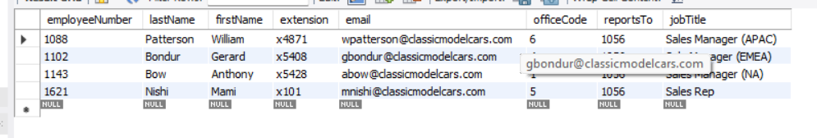

- Find all the customers who have set their state while filling the forms and Lives in USA and credit limit is between 100000 and 200000.

SELECT *
FROM customers
WHERE state IS NOT NULL
AND country = 'USA'
AND creditLimit BETWEEN 100000 AND 200000;

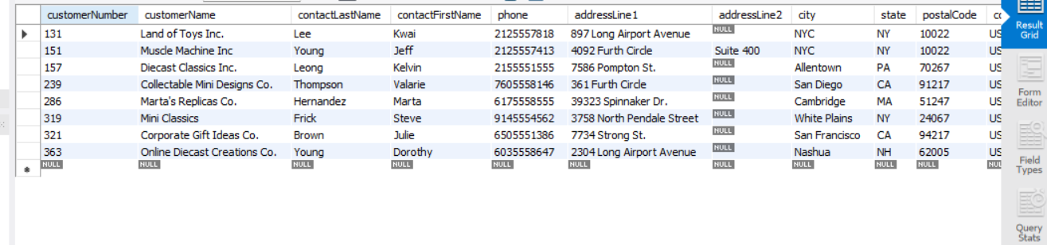
- Find all the employees who report to Sales Managers of all types.

SELECT
e.employeeNumber,
e.firstName,
e.lastName,
e.jobTitle,
mgr.jobTitle AS managerJobTitle
FROM employees e
JOIN employees mgr ON e.reportsTo = mgr.employeeNumber
WHERE mgr.jobTitle LIKE '%Sales Manager%';

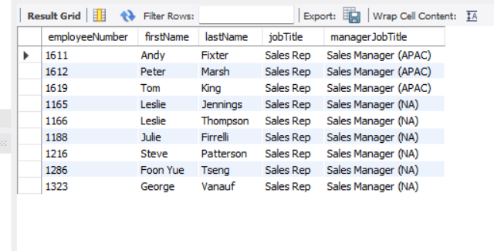

- Find the average credit limit of customers of each country.

SELECT
country,
COUNT(customerNumber) AS totalCustomers,
ROUND(AVG(creditLimit), 2) AS avgCreditLimit
FROM customers
GROUP BY country
ORDER BY avgCreditLimit DESC;

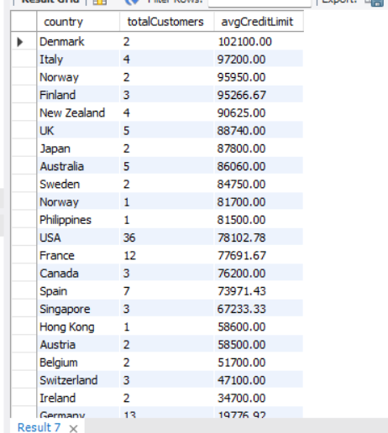

- Find the total no. of orders for each date and customer. Show only dates with total number of orders greater than 10 for date and customer.

SELECT
o.orderDate,
o.customerNumber,
c.customerName,
COUNT(o.orderNumber) AS totalOrders
FROM orders o
JOIN customers c ON o.customerNumber = c.customerNumber
GROUP BY o.orderDate, o.customerNumber, c.customerName
HAVING COUNT(o.orderNumber) > 10;

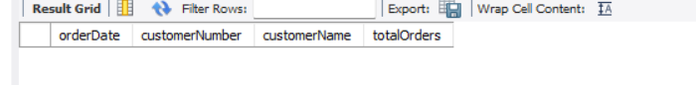

- Find the name of the supervisor, job title of supervisor and total no. of supervisee using subquery. (With out using Join operation)

SELECT
CONCAT(firstName, ' ', lastName) AS supervisorName,
jobTitle AS supervisorJobTitle,
(
SELECT COUNT(*)
FROM employees sub
WHERE sub.reportsTo = mgr.employeeNumber
) AS totalSupervisees
FROM employees mgr
WHERE (
SELECT COUNT(*)
FROM employees sub
WHERE sub.reportsTo = mgr.employeeNumber
) > 0

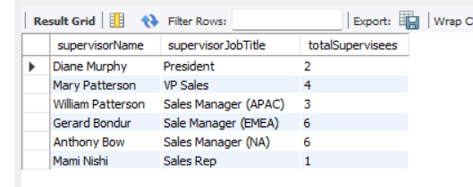
- Find the name of the supervisor, job title of supervisor and total no. of supervisee using subquery. (With using Join operation)

SELECT
CONCAT(mgr.firstName, ' ', mgr.lastName) AS supervisorName,
mgr.jobTitle AS supervisorJobTitle,
COUNT(sub.employeeNumber) AS totalSupervisees
FROM employees mgr
JOIN employees sub ON sub.reportsTo = mgr.employeeNumber
GROUP BY mgr.employeeNumber, mgr.firstName, mgr.lastName, mgr.jobTitle;
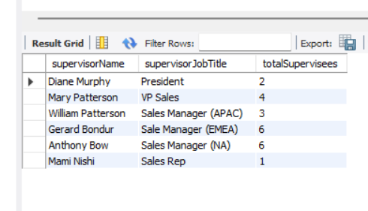
- Find all customers with a credit limit greater than average credit credit limit using WITH Clause.

WITH avg_credit AS (
SELECT AVG(creditLimit) AS avgLimit
FROM customers
)
SELECT
c.customerNumber,
c.customerName,
c.country,
c.creditLimit,
ROUND(a.avgLimit, 2) AS avgCreditLimit
FROM customers c
CROSS JOIN avg_credit a
WHERE c.creditLimit > a.avgLimit;


- Find the rank of customer. [Customer with highest credit limit have 1 rank and Customer with lowest credit limit have highest rank]. Then, find the customer with the third highest credit limit.

SELECT
customerNumber,
customerName,
creditLimit,
RANK() OVER (ORDER BY creditLimit DESC) AS creditRank
FROM customers
ORDER BY creditRank;



SELECT *
FROM (
SELECT
customerNumber,
customerName,
creditLimit,
RANK() OVER (ORDER BY creditLimit DESC) AS creditRank
FROM customers
) ranked
WHERE creditRank = 3;

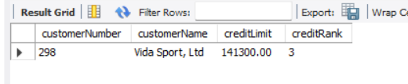
- Generate a report that shows total no. of employees working in each office.
SELECT
o.officeCode,
o.city,
o.country,
COUNT(e.employeeNumber) AS totalEmployees
FROM offices o
LEFT JOIN employees e ON o.officeCode = e.officeCode
GROUP BY o.officeCode, o.city, o.country;

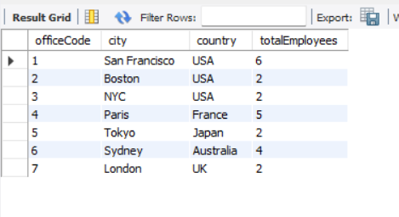
- Generate a report that shows total no. of customers visited each office.

SELECT
o.officeCode,
o.city,
o.country,
COUNT(c.customerNumber) AS totalCustomers
FROM offices o
LEFT JOIN employees e ON o.officeCode = e.officeCode
LEFT JOIN customers c ON e.employeeNumber = c.salesRepEmployeeNumber
GROUP BY o.officeCode, o.city, o.country;

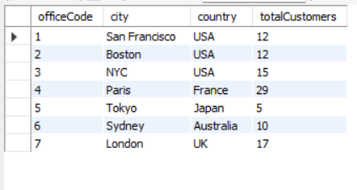
- Generate a report that shows total payment received by each office using payment tables and essential tables. The report should show the office name, state and country, along with total payments made.

SELECT
o.officeCode,
o.city,
o.state,
o.country,
ROUND(SUM(p.amount), 2) AS totalPaymentsReceived
FROM offices o
JOIN employees e ON o.officeCode = e.officeCode
JOIN customers c ON e.employeeNumber = c.salesRepEmployeeNumber
JOIN payments p ON c.customerNumber = p.customerNumber
GROUP BY o.officeCode, o.city, o.state, o.country;

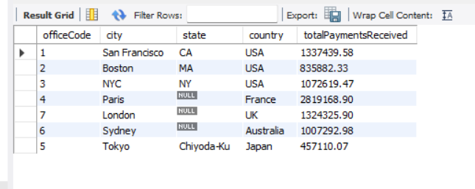
- Generate a report that shows total sales(in amount) by each office using order details table and other essential tables.

SELECT
o.officeCode,
o.city,
o.state,
o.country,
ROUND(SUM(od.quantityOrdered * od.priceEach), 2) AS totalSales
FROM offices o
JOIN employees e ON o.officeCode = e.officeCode
JOIN customers c ON e.employeeNumber = c.salesRepEmployeeNumber
JOIN orders ord ON c.customerNumber = ord.customerNumber
JOIN orderdetails od ON ord.orderNumber = od.orderNumber
GROUP BY o.officeCode, o.city, o.state, o.country;

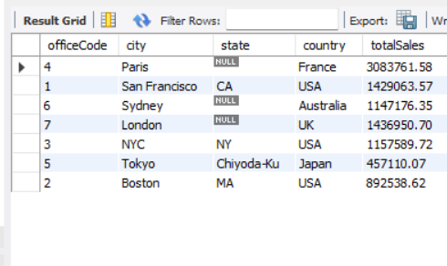
- Generate a report that shows total payment pending for each office.

WITH office_sales AS (
SELECT
o.officeCode,
o.city,
o.state,
o.country,
ROUND(SUM(od.quantityOrdered * od.priceEach), 2) AS totalSales
FROM offices o
JOIN employees e ON o.officeCode = e.officeCode
JOIN customers c ON e.employeeNumber = c.salesRepEmployeeNumber
JOIN orders ord ON c.customerNumber = ord.customerNumber
JOIN orderdetails od ON ord.orderNumber = od.orderNumber
GROUP BY o.officeCode, o.city, o.state, o.country
),
office_payments AS (
SELECT
o.officeCode,
ROUND(SUM(p.amount), 2) AS totalPaid
FROM offices o
JOIN employees e ON o.officeCode = e.officeCode
JOIN customers c ON e.employeeNumber = c.salesRepEmployeeNumber
JOIN payments p ON c.customerNumber = p.customerNumber
GROUP BY o.officeCode
)
SELECT
s.officeCode,
s.city,
s.state,
s.country,
s.totalSales,
COALESCE(p.totalPaid, 0) AS totalPaid,
(s.totalSales - COALESCE(p.totalPaid, 0)) AS totalPending
FROM office_sales s
LEFT JOIN office_payments p ON s.officeCode = p.officeCode;

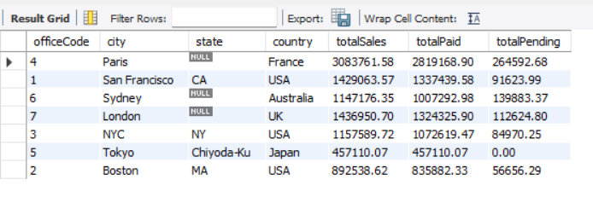

- Find the creditLimit of each person, proportion of creditLimit of each person in each country. [Proportion of person in USA = creditLimit of that person / sum(creditLimit of all person in USA]

SELECT
customerNumber,
customerName,
country,
creditLimit,
SUM(creditLimit) OVER (PARTITION BY country) AS countryCreditTotal,
ROUND(
creditLimit / SUM(creditLimit) OVER (PARTITION BY country),
4
) AS proportionInCountry
FROM customers
WHERE creditLimit IS NOT NULL;

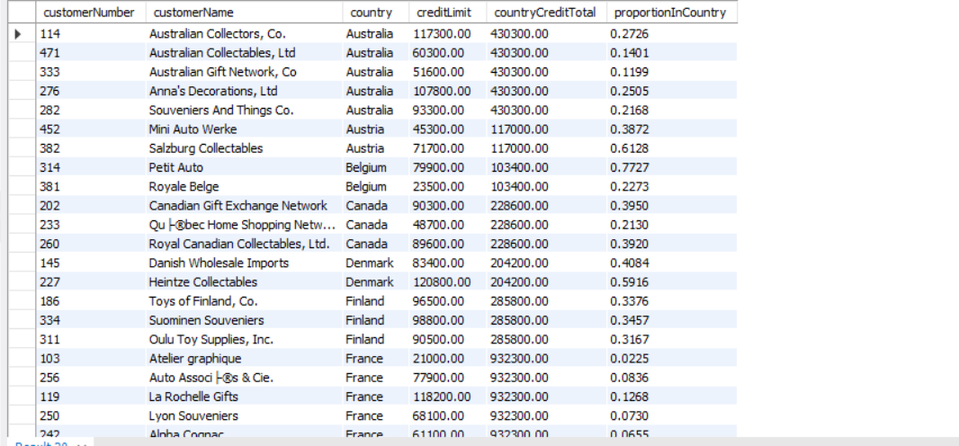

- Create a view showing the customer name, complete address, and their total number of orders.

CREATE OR REPLACE VIEW vw_customer_orders AS
SELECT
c.customerNumber,
c.customerName,
CONCAT_WS(', ',
c.addressLine1,
c.addressLine2,
c.city,
c.state,
c.postalCode,
c.country
) AS fullAddress,
COUNT(o.orderNumber) AS totalOrders
FROM customers c
LEFT JOIN orders o ON c.customerNumber = o.customerNumber
GROUP BY
c.customerNumber,
c.customerName,
c.addressLine1,
c.addressLine2,
c.city,
c.state,
c.postalCode,
c.country;

-- Query the view
SELECT * FROM vw_customer_orders ;

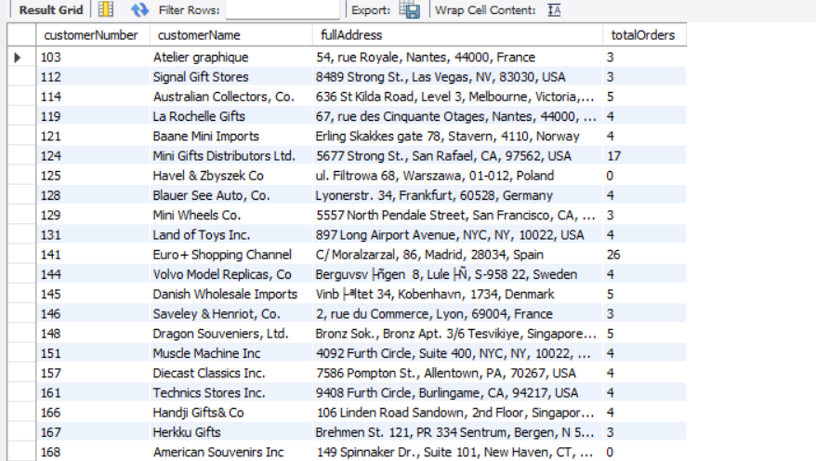
- Update the country of a customer (use any one record).

UPDATE customers
SET country = 'Canada'
WHERE customerNumber = 103;

-- Verify the update
SELECT customerNumber, customerName, country
FROM customers
WHERE customerNumber = 103;

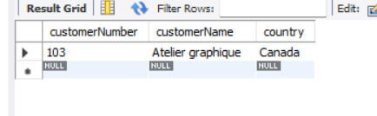
- Delete all payments below 20,000.
DELETE FROM payments
WHERE amount < 20000;

-- Verify no low-amount records remain
SELECT MIN(amount) AS minAmountAfterDelete FROM payments;

- Add new payments manually for an existing customer.

INSERT INTO payments (customerNumber, checkNumber, paymentDate, amount)
VALUES (112, 'CHK-NEW-2024', '2024-05-01', 55000.00);

-- Verify the inserted row
SELECT *
FROM payments
WHERE customerNumber = 112
ORDER BY paymentDate DESC;
